

## Role of Consumer behavior in

## design thinking process

## Consumer Behavior

**Alternate Assessment by**

**Sanjana M**

**Hemanth Srinivasan**

**Pramila Dalavai**

**Under Guidance of**

**Prof. Madhav Murthy Associate Professor**

**(Department of Mechanical Engineering) BMS College of Engineering, Bangalore**

**B. M. S. COLLEGE OF ENGINEERING**

**PB 1908, Bull Temple Road, Bengaluru – 560 019**



**Certificate**

## Role of Consumer behavior in

## design thinking process

**is a bonafide work carried out by**

**Sanjana M**

**Hemanth Srinivasan**

**Pramila Dalavai**

in partial fulfillment for the award of Bachelor of Engineering in Mechanical Engineering of the Visvesvaraya Technological University, Belgaum, during the year 2020– 21. It is certified that all corrections / suggestions indicated for internal assessment have been incorporated in the report deposited in the departmental library. The Alternate assessment has been approved as it satisfies the academic requirements in respect of **Consumer Behavior**() prescribed for the said degree.

**Signature of Guide Signature of HOD**

**(Prof. Madhav Murthy) ( Dr. Rudra Naik)**

**Declaration**

We hereby declare that the project work entitled Role of Consumer behavior in design thinking processhas been independently carried out by us at the Department of Mechanical Engineering, under the guidance of Guide Name, Designation, Department of Mechanical Engineering, B. M. S. College of Engineering, Bengaluru, in partial fulfillment of the requirements of the degree of Bachelor of Engineering in Mechanical Engineering of Visvesvaraya Technological University, Belagavi.

We further declare that we have not submitted this report either in part or in full to any other university for the award of any degree.

**Sanjana M**

**Hemanth Srinivasan**

**Pramila Dalavai**

**Place**: Bengaluru

**Date**: 14/05/2021

**Contents**

**Abstract**

**Introduction - Design Thinking**

1.1 What is design thinking ?

1.2 Importance of Design Thinking Process

1.3 Stages of Design Thinking

1.3.1 Empathize

1.3.2 Define

1.3.3 Ideate

1.3.4 Prototype

1.3.5 Test

**Background**

2.1 Challenges Faced

**Consumer Behavior**

3.1 Consumer needs and wants

3.2 Role of consumer behavior in decision thinking process

3.3 Tools and model

**Marketing**

4.1 Research methodology

4.2 Design Centric

4.3 Building better experience

**Influence on the company**

5.1 Necessary changes made

5.2 Bridge between Consumer, Product, and Design Thinking Process

**Innovative Strategies**

6.1 Innovation policies

**References**

## Abstract

Design thinking begins with reclassifying the job consumers play in our product strategy. To foster a consumer driven plan reasoning, organizations should change their way to deal with further develop cooperation with architects and promoting groups. Google the expression "plan thinking" and you'll get around 1.5 billion results. It's quite possibly the most looked-through term in business today as organizations and marketers hope to put the consumer at the focal point of their product and CX plan. Furthermore, all things considered.

But then, just a little level of organizations today have executed plan thinking definitively – utilizing consumer input to shape current and future product development.

There are a bunch of normal difficulties or holes that sway an organization's capacity to take on a consumer-driven or consumer-driven plan theory. Above all else, organizations are regularly more fixated on their own products and development pipeline than they are with addressing the particular requirements of their objective consumers.

Another normal hole is the distinction between the product configuration, designing, deals, and advertising groups, or an absence of a shared vision for how consumer experiences and design thinking will be applied.

Considering that outline, our project includes a few vital regions for brands to look into the role of consumer behavior to effectively apply the design thinking process to further develop product and consumer experiences.

## Introduction

**1.1 What is Design Thinking ?**

Design Thinking is a process for making products, services and experiences where you put your objective customer at the focal point of your product advancement cycle. Set off to construct a "base suitable product" that tackles a particular customer need or issue, and repeat after some time to improve.

While that generally sounds extraordinary in principle, we've all accomplished instances of products planned with no reasonable objective customer or customer need at the top of the priority list. Here are only a couple of models:

1. Coke
2. Google glass

**1.2 Importance of Design Thinking Process**

‘Marketing’ is regularly called the experience economy. The last option term was first portrayed in an article distributed in 1998 by B. Joseph Pine II and James H.Gilmore, named "The Experience Economy".[2] They portrayed the experience economy as the following economy following the agrarian economy, the modern economy, and the latest help economy. Pine and Gilmore contend that organizations should coordinate noteworthy occasions for their clients, and that memory itself turns into the item — the "experience".

Further developed experience organizations can start charging for the worth of the "change" that an encounter offers, e.g., as training contributions would do assuming they had the option to take part in the worth that is made by the informed individual (Lonsway, 2009).This, they contend, is a characteristic movement in the worth added by the business over or more its bits of feedbacks (Pine and Gilmore, 1999). The experience economy is too viewed as the primary support for client experience by the executives.

As an outcome, showcasing has detonated in numerous thoughts and ideas, for example, passionate marking, client bits of knowledge, publicly supporting, lovemarks, 3D advertising, client esteem advertising, gamification, neuromarketing, SEO, ethnographic research, tactile marking, sidelong promoting and design thinking.

**1.3 Stages of Design Thinking Process**

**1.3.1 Empathize**

In the "Empathize" the essential target is to place oneself in the circumstance of the "consumer" and to pose open finished inquiries. The compassionate arrangement ("Why?") becomes the overwhelming focus. The tool of the "personas" in this period of Design Thinking can anyway prompt an extension of sympathizing promoting. This apparatus powers every one of those required to take on a human-focused concentration and along these lines improves the individual touch: "it focuses on the requirements of the consumer– not speculative 'market portions' – as a wellspring of motivation and knowledge."

The storytelling works with the union and prompts a solidness that discharges more feelings than consumer’s behavior or market fragment portrayals.Assuming one remembers that later on, many statistical surveying results will be founded on the examination of "enormous information", plainly the developing capability of Design Thinking in regards to sympathizing develop unequivocally to keep instinct and appearance in balance.

Human knowledge is expected to understand information; Design Thinking can be considered to be one method for consolidating instinct and innovativeness close by investigation The logical methodology of Design Thinking further assists with trying not to over-engineer in this stage. For specific subjects it might seem okay to depend on common sense– and, if necessary , to cease totally from statistical surveying.

**1.3.2 Define**

An outright strength of the methodology of Design Thinking is that it is truly motivating and furthermore engaging. Focusing on producing something totally new yet at the equivalent time planned sets free innovative energy and moves all interested parties: "Plan is about making aim genuine. When you plan, something new is brought into the world with reason." Marketing normally begins with the examination of challenge and shortage" (needs) – Design Thinking turns it around and begins arrangement orientedly. It could assist with improving the conventional marketing process through an answer-put together reasoning methodology that focuses with respect to work on future outcomes and also begins with the objective to be accomplished. Subsequently, marketing would turn into substantially more moving.

**1.3.3 Ideate**

Design Thinking as a creative process is an interdisciplinary process by definition. Consumer’s subject specific knowledge comes into the picture. When visualized consumer’s behavior in “ideate” , Curiosity or comprehensive “know-how” behavior can be considered as the vertical bar and Environment or functions of new product design can be considered as a horizontal bar.

Classic customer surveys lead to situations where customers are overstrained because they don't know how a new product innovation should look like. Through ideation, one can enhance their “thinking alternative” behavior by trying to widen their choice options; this would lead to better decisions. Hence one can strive to evaluate as many fundamental versions as possible.

**1.3.4 Prototype**

It's an ideal opportunity to test! Through experimentation, the group distinguishes which of the potential arrangements can best tackle the recognized problem(s). This normally will incorporate downsized forms of the products or services being referred to so we can introduce and get input from consumers whom it's planned to serve.

The objective is to begin with a low-devotion form of the expected arrangement and further develop it over the long run dependent on input. Starting with a paper model can assist us with adapting rapidly with negligible exertion. The model ought to be a sensible portrayal of the arrangement that permits you to acquire a comprehension of what works and doesn't work. It is changed and refreshed dependent on input from the Test work in an iterative cycle. The minimal expense, lightweight nature of prototyping likewise permits us to foster numerous answers for test couples to distinguish the most ideal answer for meeting those neglected consumer needs.

**1.3.5 Test**

The entirety of the work and data meet up to test the product in the last stage. It's vital to take note of that this is as yet an intelligent stage. We need to hear from customers again — similarly as in the Empathize stage. The thing that matters is that we show them our model to get criticism on whether or not it tackles customer’s concern.

Testing is fundamental on the grounds that everything, eventually, ought to be about individuals who will utilize our products. This moment's the opportunity to return to the issue articulation and ensure the end arrangement is addressing those requirements and settling dissatisfactions.

We need to see the consumer's opinion on our thoughts regarding design. This stage takes into account all subtleties to be flushed out and refined to create the best solution possible.

## Background

**2.1 Challenges Faced**

## 

## Consumer Behavior

**3.1 Consumer needs and wants**

**3.2 Role of consumer behavior in decision thinking process**

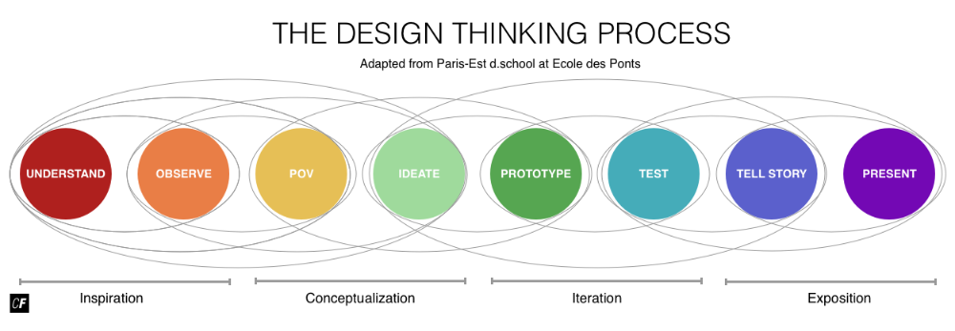

fig 1: Process model of design thinking

| **Consumer’s**  **Behavior** | **Goal of Design Thinking Process step** | **Collect inputs/ Sources** | **Process** | **Outcome** |
| --- | --- | --- | --- | --- |
| Understand | Collect existing information | Secondary research | Collect Media | Collect materials, then document |
| Observe | Gather insights about consumer’s needs | Qualitative research (interviews) | Constitute Problem definition, Design challenges, subject of the product / service | Photographs, notes, documents, transcripts of the product |
| Storytelling | Exchange consumers/ product’s survey results | Insights about user’s needs | Verbal narration/ report concurrent writing down | Bring all product ideas on the same level |
| Clustering insights | Structure all insights | Sketches | Grouping of similar insights and finding titles for each consumer segments | Rearrange insights |
| Synthesis | Clustering, Visual alignment of the insights in framework or as consumer’s stereotype | Written insights | Condense insights into a visual representation, about the consumer’s needs, identifying the plan for improvements | Framework / Persona |
| Point of View | Micro theory of consumer’s needs | Framework /  Persona | Search for the analogies | Point of view as metaphoric user perspective |
| Brainstorming question | Generate problem statement that addresses the previously defined problem | Point of view | Phrased brainstorming question | “How might we..”  “How to design and structure the product ..” |
| Ideation | Generate ideas for possible solutions to the defined problem/ consumer’s need | Brainstorming | Post it notes | Write down the ideas |
| Clustering Ideas | Structure all the ideas | Group according to specific criteria (most useful, most feasible, etc) | Sketch the ideas | Rearrange the ideas |
| Voting | Decide | all ideas | stick labels | one idea |
| Prototype | Representation of the concept | Selected tools / Materials | Prototyping , modeling | Prototype of the product |
| Test | Gather feedback from customer and stakeholders about the concept of the prototype of the product | Prototype, maybe questionnaire | Show the prototype to the potential users. Let them work with it. | Positive or negative feedback, quotes, documentation of the testing. |

**3.3 Tools and Models**

## Marketing

**4.1 Research Methodology**

Design Thinking can likewise assist with forestalling an excessively restricted viewpoint of promoting on consumer and consumer gatherings – and consequently cause a widening of the point of view. In the portrayal of Design Thinking as "human–focused way to deal with issue tackling" and as "human driven perspective" individually, plainly it ought not simply be about client direction or on the other hand "client centricity", yet that the accentuation ought to be on the more extensive thought of "human-centricity". It focuses on the fact that it is important to recognize a more extensive perspective on the human component in all innovations and associations ("compassion in real life").Despite the fact that customer direction is certainly significant, it ought not be the main concentration of an organization inside the development interaction.

Comparatively as a brand the executives has widened somewhat recently to coordinate worker conduct angles, the showcasing the board interaction should zero in favoring the human job and along these lines on all people involved (for example chiefs, workers of different offices, neighbors, investors, vendors, accomplices – not just clients). The mix of this Design Thinking viewpoint into advertising the executives would fortify the cross-useful meaning of advertising the executives and upgrade its multidisciplinarity.

**4.2 Design Centric**

**4.3 Building Better Experience**

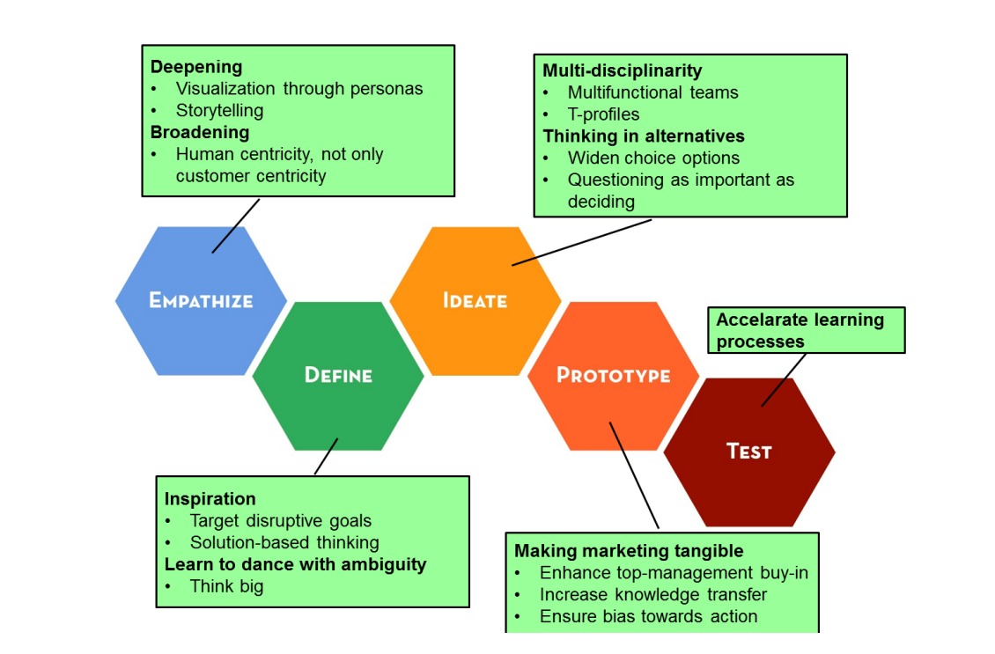

fig 2: Marketing principles from Design Thinking

## Influence on the company

**5.1 Necessary changes made**

**5.2 Bridge between Consumer, Product, and Design Thinking Process**

## Innovative Strategies

**6.1 Innovation policies**

## References

[1]<https://martech.org/design-thinking-starts-with-redefining-the-role-customers-play-in-your-product-strategy/>

[2] Dziadkiewicz, A., 2017. Customer value development in the light of design thinking approach. *Journal of positive management*, *8*(3), pp.58-68.